PRACTICAL 1

Aim: Install Android Studio Create a virtual device, Create and Run Hello World on emulator and device, Explore project layout, Generate and view log statements, Explore manifest file.

Steps to Install Android Studio on MacOS:
- Launch the Android Studio DMG file.
- Drag and drop Android Studio into the Applications folder, then launch Android Studio.
- Choose whether to import previous Android Studio settings, then click OK.
- Complete the Android Studio Setup Wizard, which includes downloading the Android SDK components that are required for development.

Creating a Virtual Device:
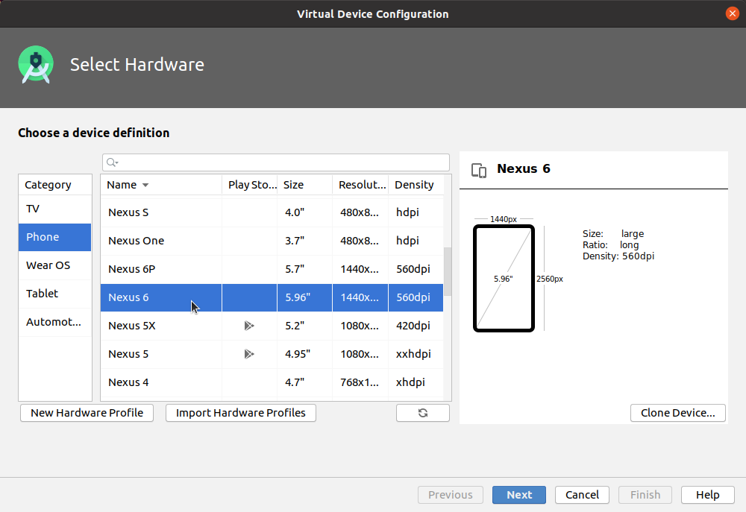
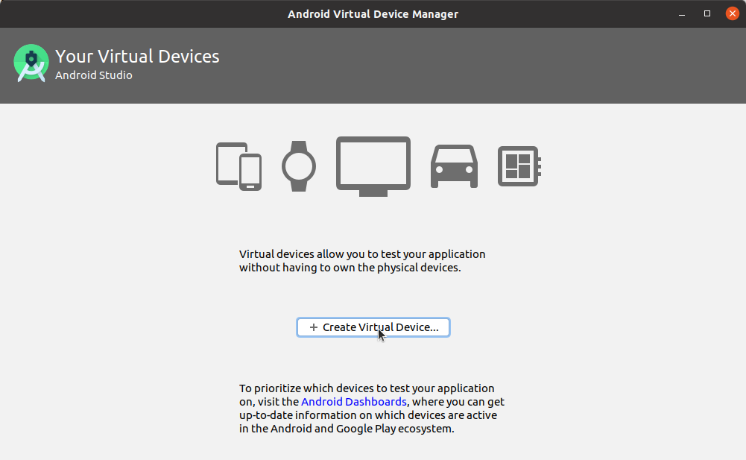

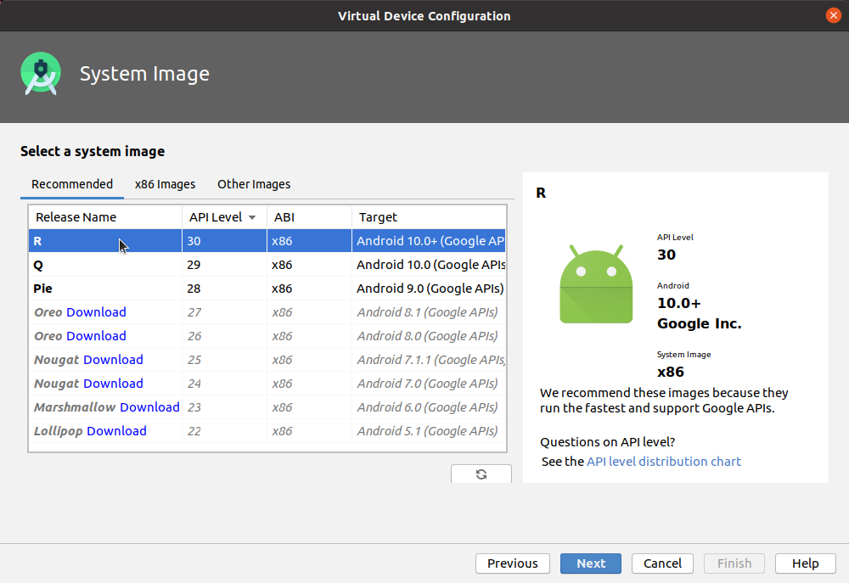
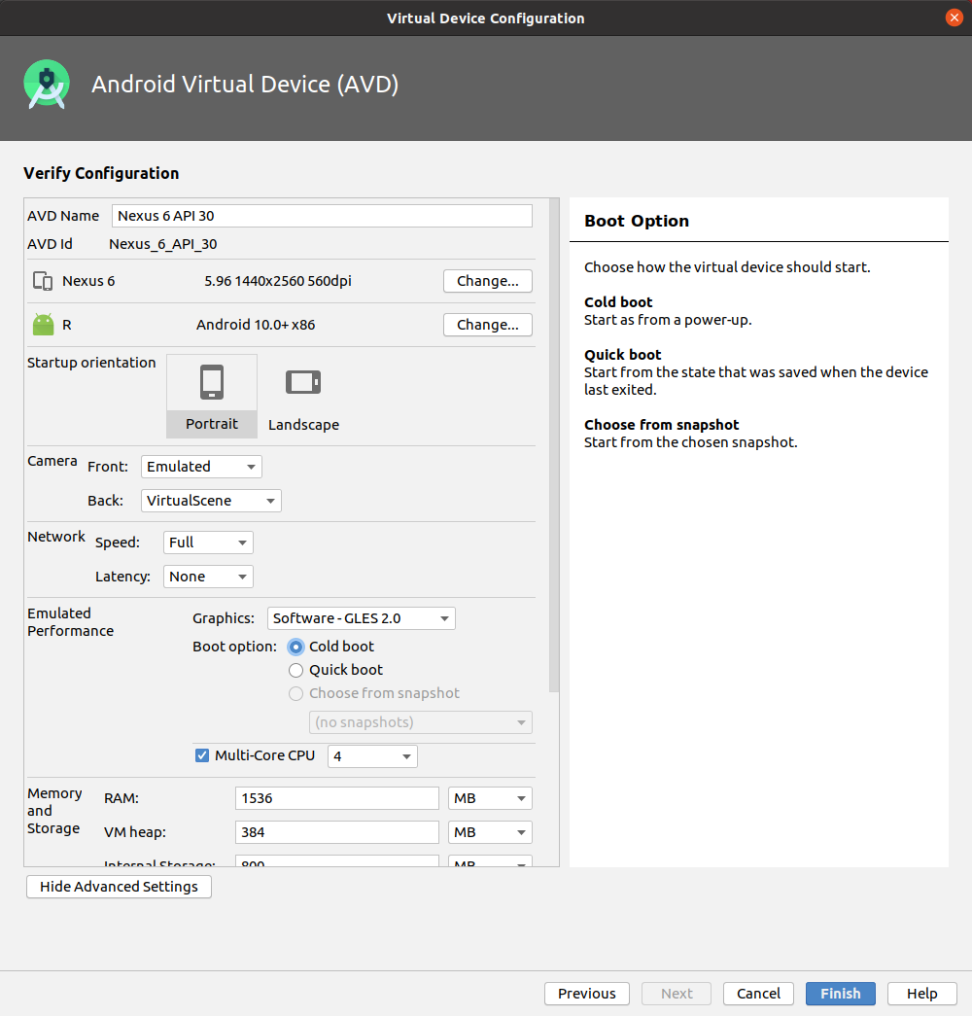

Code:
JAVA FILE: (MainActivity.java)
package com.example.practical1;
import androidx.appcompat.app.AppCompatActivity;
import android.os.Bundle;
public class MainActivity extends AppCompatActivity {
@Override
protected void onCreate(Bundle savedInstanceState) {
super.onCreate(savedInstanceState);
setContentView(R.layout.activity_main);
}
}

XML FILE: (activity_main.xml)
<?xml version="1.0" encoding="utf-8"?>
<androidx.constraintlayout.widget.ConstraintLayout xmlns:android="http://schemas.android.com/apk/res/android"
xmlns:app="http://schemas.android.com/apk/res-auto"
xmlns:tools="http://schemas.android.com/tools"
android:layout_width="match_parent"
android:layout_height="match_parent"
tools:context=".MainActivity">

<TextView
android:id="@+id/textView"
android:layout_width="wrap_content"
android:layout_height="wrap_content"
android:layout_marginTop="50dp"
android:text=" Name: Angat Shah \n Enrollment No: 202203103510097 \n Branch: B.Tech CSE"
app:layout_constraintEnd_toEndOf="parent"
app:layout_constraintHorizontal_bias="0.497"
app:layout_constraintStart_toStartOf="parent"
app:layout_constraintTop_toTopOf="parent"
tools:ignore="MissingConstraints" />

<TextView
android:layout_width="wrap_content"
android:layout_height="wrap_content"
android:text="HELLO WORLD"
android:textSize="21dp"
app:layout_constraintBottom_toBottomOf="parent"
app:layout_constraintEnd_toEndOf="parent"
app:layout_constraintStart_toStartOf="parent"
app:layout_constraintTop_toTopOf="parent" />
</androidx.constraintlayout.widget.ConstraintLayout>

Output:

